F28DM – Query Optimization Tutorial

The Company schema is shown below (primary keys underlined, foreign keys in italics), together with a small sample of the data.

**DBEmployee** (ssn:6 digits, lastname:text(20), firstnames:text(20), dateOfBirth:date,  
 gender: [M,F],salary : integer*, empdNum*:integer(1..100), *supssn*: 6 digits)

*‘ssn’ is the primary key  
 ‘empdNum’ is a foreign key referencing’ dNum’ in Department  
 ‘supssn’ is a foreign key referencing ‘ssn’ in Employee*

**DBDepartment** (dNum: integer(1 .. 100), dName:text(15), *mgsSsn*: 6 digits, mgrStartDate:date)

*‘dNum’ is the primary key. ‘mgrSsn’ is a foreign key referencing ‘ssn’ in Employee*

**DBLocation** *(ldNum*:integer(1..100), *loc*:text(15))

*‘ ldNum’ and ‘loc’ form a composite primary key.*

*‘ldNum’ is a foreign key referencing ‘dNum’ in Department*

**DBProject** (pNum: integer(1..20), pName:text(20) ) *‘pNum’ is the primary key*

**DBWorksOn**(*wssn*: 6 digits, *wpNum*: integer(1..20), hours:integer)

*‘wssn’ and ‘wpNum’ together form a composite primary key*

*‘wssn' is a foreign key referencing ‘ssn’ in Employee*

*‘wpNum’ is a foreigh key referencing ‘pNum’ in Project*

**DBDeadline (***projPNum,* dLineDate, dLineType)

*‘dLinepNum’ and ‘dLineDate’ together form a composite foreign key*

*‘dLinepNum’ is a foreign key referencing ‘pNum’ in Project*

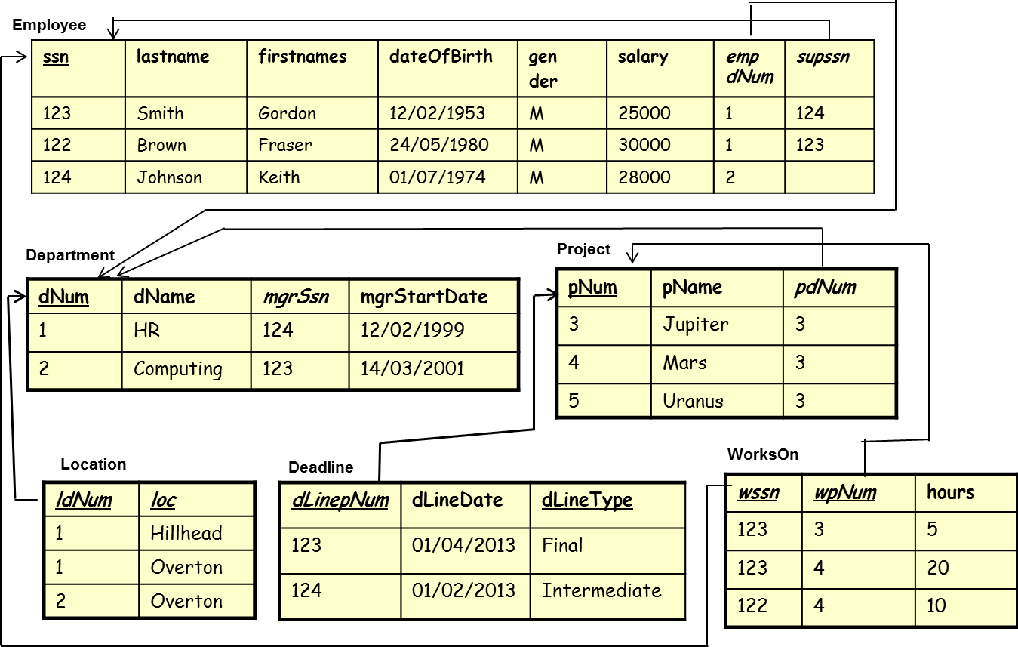

Draw and optimize query plans for the following queries. Assume that there are indexes defined for all primary keys.

1. Return the ssn, last name and date of birth of all male employees

SELECT ssn, lastname, dateOfBirth   
FROM DBEmployee   
WHERE gender = 'M';

1. Find the name of the department managed by Fraser Brown.

SELECT dName   
FROM DBDepartment, DBEmployee   
WHERE mgrSsn = ssn AND  
 lastname = 'Brown' AND   
 firstnames = 'Fraser';

1. Summarise employee names and ssn, the number and name of their department and the locations that this department is based in.

SELECT ssn, firstnames, lastname, empdNum, dName, loc  
FROM DBEmployee, DBDepartment, DBLocation  
WHERE empdNum = dNum AND  
 dNum = ldNum;

1. How many hours does Sanjay James work on the Jupiter project?

SELECT hours   
FROM DBWorksOn, DBProject, DBEmployee  
WHERE wssn = ssn AND   
 wpNum = pNum AND   
 lastname = 'James' AND   
 firstnames = 'Sanjay' AND  
 pName = 'Jupiter';

1. How does the addition of the index Employee(lastname,firstnames) affect the plans?
2. Suggest an index that may improve the performance of the query in question 4? In what circumstances would it help?